Thermal and Mechanical Properties of Cementitious Composites for Additive Construction of Energy-Saving Habitats
Downloaded from ascelibrary.org by University of Liverpool on 07/22/25. Copyright ASCE. For personal use only; all rights reserved.
Hongyu Zhou¹; Adam L. Brooks²; Dominic Hanna³; and Babak Salarieh⁴
¹Dept. of Civil and Environmental Engineering, Univ. of Alabama in Huntsville, Huntsville, AL 35758, USA (corresponding author). E-mail: hz0009@uah.edu
²Dept. of Civil and Environmental Engineering, Univ. of Alabama in Huntsville, Huntsville, AL 35758, USA
³Dept. of Civil and Environmental Engineering, Univ. of Alabama in Huntsville, Huntsville, AL 35758, USA
⁴Dept. of Civil and Environmental Engineering, Univ. of Alabama in Huntsville, Huntsville, AL 35758, USA

ABSTRACT
Lightweight cementitious composites (LWCC) are cement based material combined with lightweight fillers. Because of its advantages in reducing both structural weight and thermal conductivity, it has the potential to be used in the construction of terrestrial and extraterrestrial habits. Furthermore, since it has relatively small and spherical shaped aggregates, LWCC is also suitable for extrusion based 3-D printing. In this research, a comprehensive and thorough study was carried out to investigate the effects of different lightweight fillers on both the mechanical and thermal properties of LWCC. Various lightweight fillers including three types of hollow glass microspheres (HGM) and two fly ash cenospheres (FACs) are studied in conjunction with various particle size, shell wall thickness, and volume fractions. Both mechanical and thermophysical properties were tested. The results indicated that the thermal property of LWCC is mostly governed by the volume fraction of LWFs whereas the mechanical properties are heavily affected by the type and property of LWF particles included. In addition, to understand the materials’ mechanical performance under high strain rate, split Hopkinson pressure bar (SHPB) tests were conducted for strain rate ranging from 400 s⁻¹ to 1000 s⁻¹.

INTRODUCTION

Cementitious Materials for Additive Construction
Provoked by recent advancements in additive manufacturing (Wu et al. 2016), 3D printable concrete has been explored as an alternative method to construct concrete structures (Figure 1).
3-D printing of cementitious materials has the potential to address several major challenges faced by the current concrete industry: (i) it eliminates the use of formwork (mold) and vibration that are typically necessary for consolidating wet concrete, which can significantly reduce material and labor costs involved in the formwork construction, particularly for in situ cast concrete; (ii) the highly automated construction process can reduce the material waste, cut down construction time, and reduce human error (Buswell et al. 2006; Bos et al. 2016); in addition, (iii) it allows a new approach for concrete design – the composition and property of printed material can be parametrically varied from one location to another, tuning to the optimal structural and energetic performances.

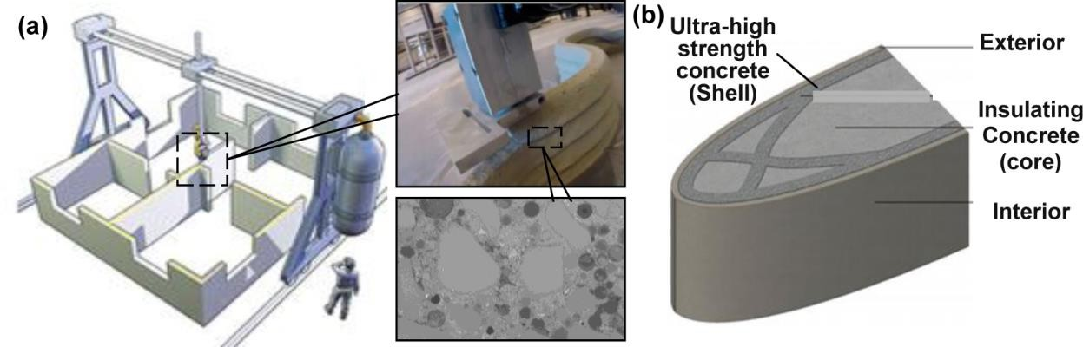

Figure 1. (a) Rendering showing additive construction with concrete, and (b) concept of a 3-D printed concrete wall section (Bos et al. 2016).
Table 1. Properties of the lightweight particle fillers.

Particle Size (μm) Wall Thickness
Density
Crush

LWF Type Material
D10
D50
D90
- t (μm)
(g/cm³)
Strength (MPa)

HGM K25 | Hollow glass | 25 | 55 | 90 | 0.85 | 0.25 | 0.75
HGM S38HS | microsphere | 19 | 44 | 70 | 1.20 | 0.28 | 5.5
HGM S60 | (HGM) | 12 | 29 | 48 | 1.49 | 0.60 | 10
FAC E106 | Fly ash cenosphere | 42.6 | 81.3 | 125.2 | 4.8 | 0.91 | 1.6-3.2
FAC E200/600 | (FAC) | 81.3 | 349.1 | 457.2 | 16.5 | 0.82 | 1.6-3.2

(a)

10
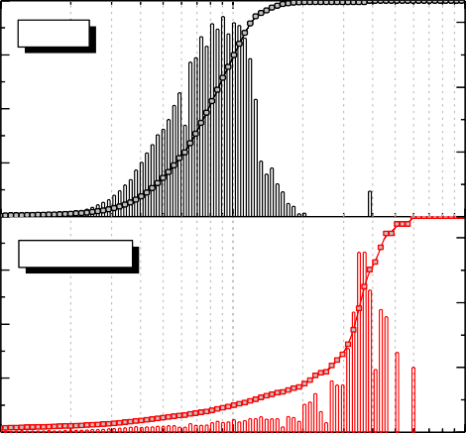
6.0
ES106
ES200/600

4.5

3.0

1.5

20 40 60

100

200 400 600

1000

90

60

30
(b)

0.0
% Volume

9

6

3

0
10

20 40 60

100

200 400 600
0
90
Accumulative Volume (%)

60

30

0
1000

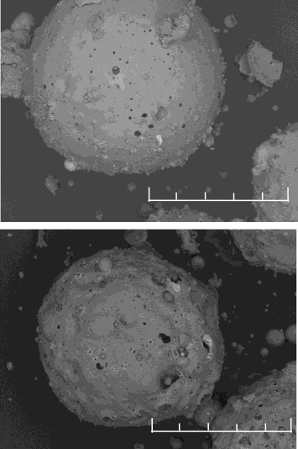
Particle Size (μm)
E106 FAC
50 μm
E200/600 FAC
300 μm
Downloaded from ascelibrary.org by University of Liverpool on 07/22/25. Copyright ASCE. For personal use only; all rights reserved.

Figure 2. (a) Particle size distribution of the fly-ash cenospheres (FAC) and (b) SEM images showing surface morphology of the FACs.
Lightweight Cementitious Composites
Lightweight cementitious composites (or LWCC) are produced by incorporating millimeter and micrometer size lightweight functional fillers (LWFs) including expanded polystyrene beads, expandable thermoplastic microspheres (Aglan et al. 2009), hollow glass microspheres (Zhang et al. 2015; Oreshkin et al. 2016), and fly-ash cenospheres (Huang et al. 2013; Hanif et al. 2017) into cementitious binder matrix. Some of the emerging LWFs are introduced herein. The use of LWCC in buildings and habitat structure brings two-fold advantages: first, it reduces structural

weight and the dead load acting on the structures which would lead to smaller structural members and foundation size (Yasar et al. 2003); secondly, the materials have lower thermal conductivity than normal weight concrete which will in turn reduce building energy consumption and provide better fire resistance (Clarke 1993). Unlike most lightweight coarse aggregates with irregular shape and porous surfaces (e.g., expanded shale clay), the lightweight particulate aggregates/fillers have much smaller particle size and are mostly spherical in shape (or have a core-shell configuration), leading to much more tightly controlled rheological properties for advanced construction process such as 3-D printing and long-distance pumping. It also allows the fine-tuning of material properties by varying material parameters such as particle size, shell thickness (stiffness), and volume fraction. Thus, an accurate knowledge of relationships between the composition, aggregate property, and the equivalent properties of the LWCC is desired for material design.
Downloaded from ascelibrary.org by University of Liverpool on 07/22/25. Copyright ASCE. For personal use only; all rights reserved.
In this research, a comparative study is conducted on the properties of lightweight cementitious composites (LWCC) mixed with two types of lightweight filler particles – i.e., hollow glass microspheres (HGM) and fly ash cenospheres (FAC). The material thermophysical and mechanical properties are investigated with respect to the lightweight filler particle type, size distribution, as well as their volume concentration. Key parameters governing the material thermal and mechanical properties are discussed, and the composition-property relationships are deduced from both experimental results and predictive models. In addition, to understand the strain-rate dependent behavior of LWCC, a set of compressive tests were conducted using the split Hopkinson pressure bar (SHPB) on LWCC containing fly-ash cenospheres. The dynamic strain-strass behavior and damage mode were investigated as functions of the strain rate.

EXPERIMENTAL PROGRAM

Material Preparation and Mixture Design
The constituent materials used for preparing the LWCC in this study include ASTM Type I- II Portland cement, silica sand, water, superplasticizer, and the lightweight fillers (LWF). The water to cement ratio (w/c) was selected at 0.43 for all mixtures. The mass of cement, sand, and water used for each cubic meter of the reference mortar (without LWF) are 531 kg/m³, 1368 kg/m³, and 228 kg/m³, respectively. The LWF used in this research include three types of hollow glass microspheres (HGM) and two types of fly ash cenospheres (FAC). For each type of LWF, different particle properties (i.e., size, density, crushing strength, and volume fraction etc.) were studied with respect to their influences on the mechanical and thermophysical properties of LWCC. For each group of LWF tested herein, four LWF volume fractions (vf) – i.e., namely 7%, 14%, 21%, and 28% of the total volume were tested and for each volume fraction the equivalent volume of regular fine aggregate (i.e., silica sand) was deducted from the mix (i.e., the amount of silica sand used for vf = 7%, 14%, 21%, and 28% are 1138 kg/m³, 937 kg/m³, 716 kg/m³, and 534 kg/m³, respectively). The air content of fresh cement mortar was measured at 2-5% according to ASTM C185 – 15a, which does not account for the air contained within the closed pores of LWF.
Hollow glass microsphere (HGM) bubbles with density ranging from 0.25 g/cm³ to 0.6 g/cm³ were used for the mixes. The HGMs used in this research are produced by 3MTM Advanced Materials. The average particle densities tested by gas pycnometry for HGM K25, S38HS, and S60 are 0.25 g/cm³, 0.38 g/cm³, and 0.60 g/cm³, respectively. The microspheres also have different particle size (in descending order), wall thickness, and isostatic crush strength as listed

in Table 1. The particle sizes were tested by laser diffraction and reported by the manufacturer. The isostatic crush strength refers to the pressure at which an average lot of material has 90% or higher survival (3M, 2009).
Downloaded from ascelibrary.org by University of Liverpool on 07/22/25. Copyright ASCE. For personal use only; all rights reserved.
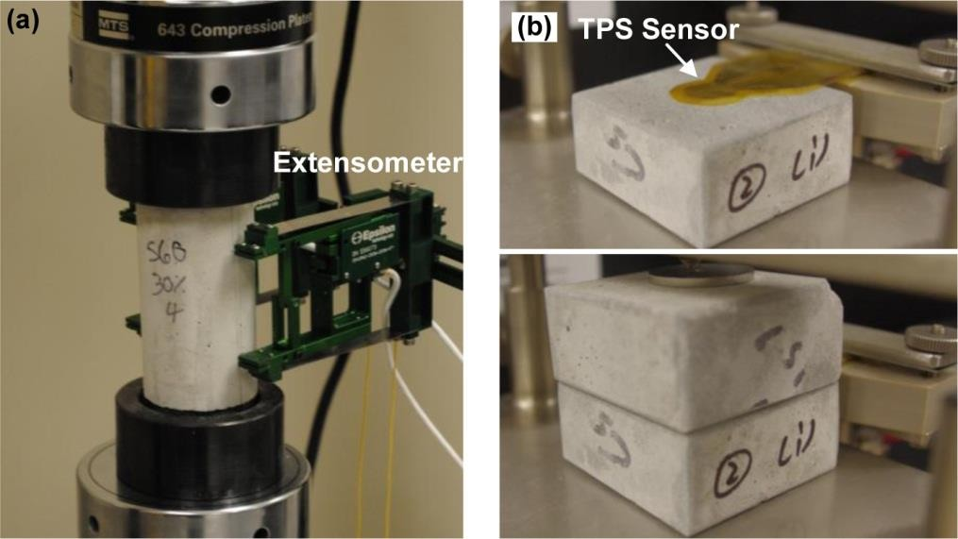

Figure 3. (a) Mechanical test setup for LWCC cylinders, and (b) the transient plane source (TPS) tests for determining thermal properties.
Two types of cenospheres with particle sizes up to 106 μm (E106) and 600 μm (E200/600) are studied in this research. X-ray Diffraction (XRD) analysis performed on the FACs indicated that the cenospheres are comprised primarily of SiO2 and Al2O3, and there is a large amount of amorphous materials with small amounts of mullite and calcite. The E200/600 also contains small amount of quartz. The particle size distributions were tested using a laser diffraction particle size analyzer (Horiba LA-950) and the particle size distributions are plotted in Figure 2
(a). The particle shell thicknesses were measured using scanning electron microscopy (SEM) imaging where the particles were embedded in epoxy and grinded using a Buehler EcoMetTM grinder/polisher to expose the section of the FAC shell. Figure 2 (b) presents the SEM images showing the surface morphologies of each type of FAC particles studied herein.

Mechanical and Thermal Testing
Mechanical properties of the LWCC mortar mixtures were tested using a MTS-810 servo- hydraulic universal testing system. The loading was carried out in a displacement-control mode at the loading rate of 0.01 mm/min. Five 50 mm diameter by 100 mm tall cylinders were tested for each mixture group. A CCD camera was staged to record the damage and failure of the specimens. The mechanical test setup is shown in Figure 3 (a).
The thermal properties (i.e., thermal conductivity and volumetric heat capacity) of LWCC were tested using the Transient Plant Source (TPS) method (ISO 2008). The TPS method uses a conducting pattern with negligible heat capacity acting simultaneously as the heating element and temperature sensor, see Figure 3 (b). To solve for the thermal constants of the tested material, the hot disk sensor is assumed to consist of a series of concentric ring heat sources located in an infinitely large sample. When the double spiral sensor is electrically heated, the time-dependent temperature increase of the tested material is recorded and the thermal conductivity and thermal diffusivity can be simultaneously obtained through a process of iteration. The TPS method provides a fast yet accurate method to measure thermal conductivity

and thermal diffusivity of materials (Log et al. 1995). The test time for each measurement normally ranges from tens of seconds to several minutes, which is substantially shorter than those of steady-state test methods (ASTM 2005). For the TPS tests, the LWCC cubes were cut into two identical halves (50×50×22mm). Then, the samples were dried in a convection oven for 24 hours and cooled down to room temperature in an air-tight desiccant cabinet to prevent condensation. The TPS tests were then performed using a HotDisk TPS-1500 thermal constant analyzer according to the ISO22007-2 (ISO22007-2, 2008). Three measurements were taken on each tested sample to ensure the consistency of the test results.
Downloaded from ascelibrary.org by University of Liverpool on 07/22/25. Copyright ASCE. For personal use only; all rights reserved.
Table 2. Density, mechanical, and thermal properties of LWCC tested.
Mix ID | LWMI  Material Type | LWF  Fraction | Air Content | Wet Density | Oven Dry Density | Compressive Strength | Thermal Conductivity
 |  | vf (%)* | (%)** | (kg/m³) | (kg/m³) | (MPa) | (W m⁻¹K⁻¹)
K25-0 | Hollow glass microsphere (3M) K25 | 0 | 5 | 2278 | 1974 | 55.1 | 2.30
K25-1 |  | 7.1 | 3 | 2236 | 1926 | 57.5 | 1.90
K25-2 |  | 14.5 | 2 | 1984 | 1737 | 46.4 | 1.33
K25-3 |  | 22.1 | 2.5 | 1737 | 1537 | 30.9 | 0.90
K25-4 |  | 29.3 | 3.5 | 1589 | 1344 | 21.5 | 0.62
S38HS-0 | Hollow glass microsphere (3M) S38HS | 0 | 3.25 | 2298 | 2027 | 46.0 | 2.18
S38HS-1 |  | 6.71 | 2.25 | 2219 | 1939 | 46.9 | 1.69
S38HS-2 |  | 13.69 | 2 | 2058 | 1830 | 52.7 | 1.36
S38HS-3 |  | 21.30 | 1 | 1871 | 1670 | 48.4 | 0.98
S38HS-4 |  | 28.59 | 1.25 | 1655 | 1434 | 35.2 | 0.66
S60-0 | Hollow glass microsphere (3M) S60 | 0 | 4.75 | 2298 | 2007 | 48.7 | 2.15
S60-1 |  | 7.07 | 3.25 | 2209 | 1932 | 55.5 | 1.79
S60-2 |  | 14.60 | 1.25 | 2089 | 1836 | 61.2 | 1.35
S60-3 |  | 22.09 | 2.5 | 1903 | 1651 | 52.2 | 0.96
S60-4 |  | 29.20 | 3.75 | 1697 | 1494 | 48.5 | 0.70
E106-0 | Fly-ash cenosphere E106 | 0 | 3.75 | 2288 | 1984 | 50.6 | 2.18
E106-1 |  | 6.75 | 2.25 | 2179 | 1893 | 54.5 | 1.77
E106-2 |  | 13.75 | 2.75 | 2054 | 1787 | 59.7 | 1.44
E106-3 |  | 21.00 | 2.75 | 1911 | 1669 | 62.8 | 1.15
E106-4 |  | 28.50 | 4.25 | 1706 | 1463 | 45.8 | 0.85
E200/600-0 | Fly-ash cenosphere E200/600 | 0 | 3.5 | 2333 | 2019 | 53.5 | 2.21
E200/600-1 |  | 5.77 | 4.75 | 2160 | 1858 | 42.9 | 1.77
E200/600-2 |  | 11.81 | 4.25 | 1992 | 1708 | 43.9 | 1.39
E200/600-3 |  | 18.21 | 5.75 | 1841 | 1553 | 40.4 | 1.07
E200/600-4 |  | 24.51 | 6 | 1655 | 1396 | 35.4 | 0.80

RESULTS AND DISCUSSION

Compressive Strength
Table 2 lists the density (oven-dry), mechanical, and thermal properties of LWCC tested in this study. The average 28-day compressive strength of LWCC mixtures with different lightweight functional fillers and volume fractions (vf) are summarized in Figure 4, where the compressive strength is plotted against oven dry density. It was observed that the compressive strength of LWCC mortars containing HGM and FAC is a function of LWF particle size and shell property (e.g., thickness) of the LWF included. When vf is small (<15%), the compressive

strength of LWCC mortars increases with higher HGM concentrations, see Figure 4 (a). This finding is believed to be due to the spherical shape of HGM, which improves the rheological property of fresh mortar mixes and reduces the air content. The compressive strength starts to decrease when the volume fraction of HGM becomes higher (> 15%) – i.e., the hollow structure of HGMs allows the stress cracks to propagate through the particle shell to cause damage and material failure. It is noted that with the same LWF volume concentration (or density), mortars having smaller size HGM particles and thicker shell yield higher mechanical strength. This trend becomes more notable when LWF volume fraction vf is high. At vf = 7%, the HGM S60 mortar is 32% (15 MPa) stronger than the mortar containing K25 particles; whereas at vf = 28%, S60 mortar is about 125% (27 MPa) stronger than the K25 mortar. It is worthwhile mentioning that the compressive strength of LWCC mortars mixed with nearly 30% (total volume fraction) of H50 and S60 HGM particles are almost the same as the reference mortar while their densities were about 25% lower than the reference mortar, see Table 2 and Figure 3 (a). This finding indicates significant potential for the design of high strength lightweight cementitious composites for structural load-bearing applications.
Downloaded from ascelibrary.org by University of Liverpool on 07/22/25. Copyright ASCE. For personal use only; all rights reserved.
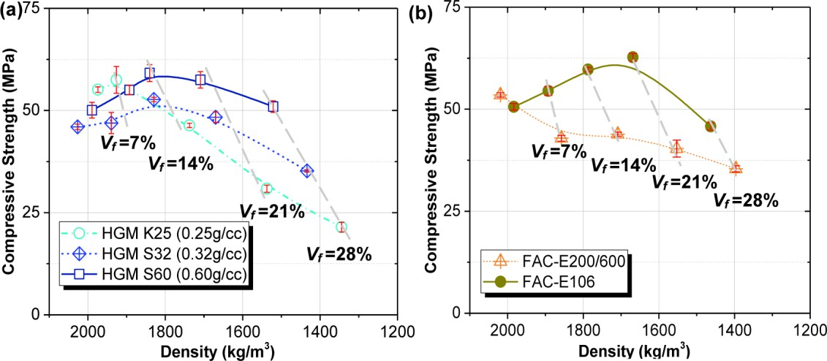

Figure 4. Compressive strength versus density for (a) LWCC with hollow glass microspheres (HGM) and (b) LWCC with fly-ash cenespheres FACs.
A similar trend was observed for LWCCs containing FACs. Generally, LWCC containing larger FAC particles (i.e., E200/600) have lower strength for given FAC volume fraction. For the LWCC group having E200/600 cenospheres, the compressive strength shows a continuously descending trend as vf becomes higher. As for E106, the mortar strength peaks at vf = 21% and it decreases rapidly when vf approaches 28%. For LWCCs with E106 FAC, the compressive strength is similar or higher than the reference mortar when the vf is less than 20-25%. It is also noted that the E200/600 mortars have higher air content, which is likely due to the larger particles size, which made the fresh mortar less flowable during mixing.

Thermal Properties
In general, the thermal conductivity of LWCC mortar decreases with the increase in LWF volume fraction vf. For the control mortar samples (without LWF), the thermal conductivity was tested between 2.1-2.2 W/m K. The thermal conductivities of LWCCs are significantly lower than that of normal weight cement mortar and concrete due to the incorporation of hollow lightweight particulate fillers. It should be mentioned that since the LWFs were used to replace

the regular fine aggregate by its equivalent volume. The decrease in thermal conductivity is partially attributed to two factors: (i) the inclusion of low conductivity LWFs in cement paste, and (ii) the decreased volume fraction of normal weight fine aggregate (i.e., silica sand, which is primarily quartz, has substantially higher thermal conductivity than cement paste.
Downloaded from ascelibrary.org by University of Liverpool on 07/22/25. Copyright ASCE. For personal use only; all rights reserved.
It was observed that the thermal conductivity of LWCC is relatively insensitive to the type and size of LWF used; rather, it is primarily dictated by the LWF volume fraction, see Figure 5. As the LWF volume fraction vf increases the equivalent thermal conductivity of LWCC decreases notably, i.e., when vf = 7%, the thermal conductivity reduces by about 30%; as vf approaches 28%, the thermal conductivity of LWCC decreases to 0.65-0.8 W/m K. For the LWF materials studied herein – i.e., HGM and FAC, the particle size and shell property have very limited effects on the thermal conductivity of LWCC mortar. LWCC containing larger particles have shown slightly higher thermal conductivity than other groups. This observation is mainly because the convective heat transfer through air enclosed in the cells reduces as the pore size becomes smaller.
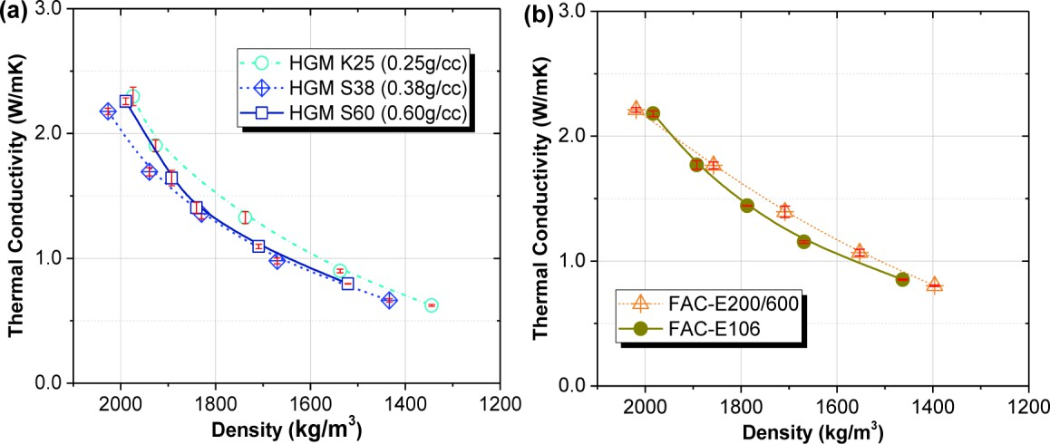

Figure 5. Thermal conductivity versus density for (a) LWCC with hollow glass microspheres (HGM) and (b) LWCC with fly-ash cenespheres FACs.
Microstructures
The microstructural characterization was carried out using scanning electron microscopic (SEM) imaging. The LWCC mortar samples for microstructural analysis were resin-impregnated using epoxy, and the resin mounted samples were then ground and polished to 0.3 μm diamond paste. SEM imaging was conducted using a Hitachi TM1000 at accelerating voltage of 15 kV. For analyzing the fracture surfaces of LWCC, fragments of the tested compression cylinders were preserved and placed on a sample holder for SEM imaging analysis.
Figure 6 presents the SEM micrographs of four different LWCCs having E 200/600, E160 FACs and K25, S60 HGMs. The volume fractions of LWF for the four LWCC groups presented in Figure 6 were nearly the same, i.e., approximately 14% of the total volume. It is noted that the E200/600 FAC have similar particle size with silica sand and the cenospheres were scattered across the mortar material, see Figure 6 (a). The shell thickness of E200/600 FAC is around 15 μm (5-10% of the particle diameter) and the shell has a microporous structure. On the other hand, the smaller FAC particles (E160) are well distributed within the cementitious binder, see Figure 6 (b). The denser, more compacted, and uniform microstructure in the E160 modified

LWCC influenced its mechanical strength and other properties of the composites including the post-crack behavior (Hanif et al. 2017). It was also observed in the experiments that the spherical shape and smooth surface of E106 and E160 FAC improved the rheological behavior of the fresh mortar mix and reduced the air content. The improved rheological behavior is critical for extrusion based construction technique such as the 3-D printing process shown in Figure 1. The K25 and S60 HGMs have similar particle size as the E160 FAC and they were both well distributed within the cementitious binder. While the low density K25 particles have greater particle size and thinner shell wall than S60. It is evident that most of the K25 and S60 HGM particles survived the mortar mixing process and breakage of LWF particles during concrete mixing are minimal.
Downloaded from ascelibrary.org by University of Liverpool on 07/22/25. Copyright ASCE. For personal use only; all rights reserved.
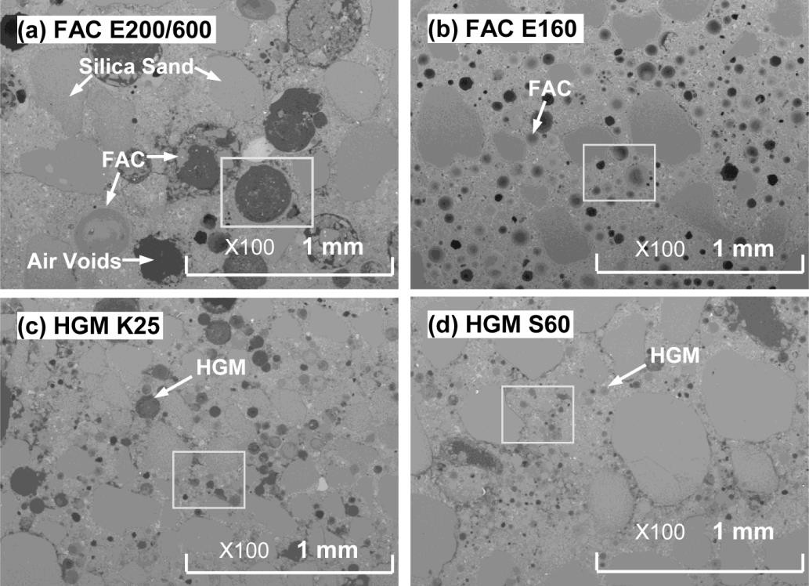

Figure 6. SEM images showing the microstructure of LWCC containing (a) E200/600 FAC;
(b) E160 FAC; (c) K25 HGM; and (d) S60 HGM. DYNAMIC TESTING USING SPLIT PRESSURE HOPKINSON BAR
To obtain the dynamic behavior of LWCC under high strain rate, a set of impact dynamic tests were performed using Split Hopkinson Pressure Bar (SHPB). Figure 7 presents the set-up of the apparatus that has been used for testing the LWCC samples containing 42% vol. FAC. The SHPB test system consisted of a striker propelled by a gas gun, an input bar, an output bar, a shock absorber and a data acquisition system where the strain readings are obtained from two strain sensors. The bar diameter of SHPB used in this study has ¾-inch (about 20 mm) diameter. The pressure in the gas gun and the striker size determine the projectile speed. The specimen is placed between the input and output bars. The impact of a striker at the free end of the input bar will impose a compressive longitudinal incident stress wave which travels along the bar. After the stress wave reaches the specimen-bar interface, the differences in mechanical impedance between the specimen and pressure bar (different material) causes the incident wave to partially reflected back into the input bar while the rest of the wave is transmitted into the sample and output bar. The incident, reflected and transmitted pulse in the pressure bar are recorded by the strain gauges attached to the input and output bar surface, respectively (see Figure 7). According

to one-dimensional elastic wave propagation theory, the stress, strain and strain rate of the specimen can be calculated as:

and
σ (t ) = Eb
Ab ε
A T
(t )
(1)


ε (t ) = −2cb ε
L R
(t )
(2)

where Eb, Ab and cb are the Young’s modulus, cross-sectional area and longitudinal wave speed of the bars, respectively; εT and εR denote the amplitudes of the transmitted and reflected strain pulses, and A and L are the cross-sectional area and length of the specimen, respectively. The expression of strain rate in Equation (2) may be integrated with respect to time to obtain the strain:

ε ( )
−2c
t
ε (τ ) τ

t = ^{b} ∫ d
R
(3)

L 0
Downloaded from ascelibrary.org by University of Liverpool on 07/22/25. Copyright ASCE. For personal use only; all rights reserved.
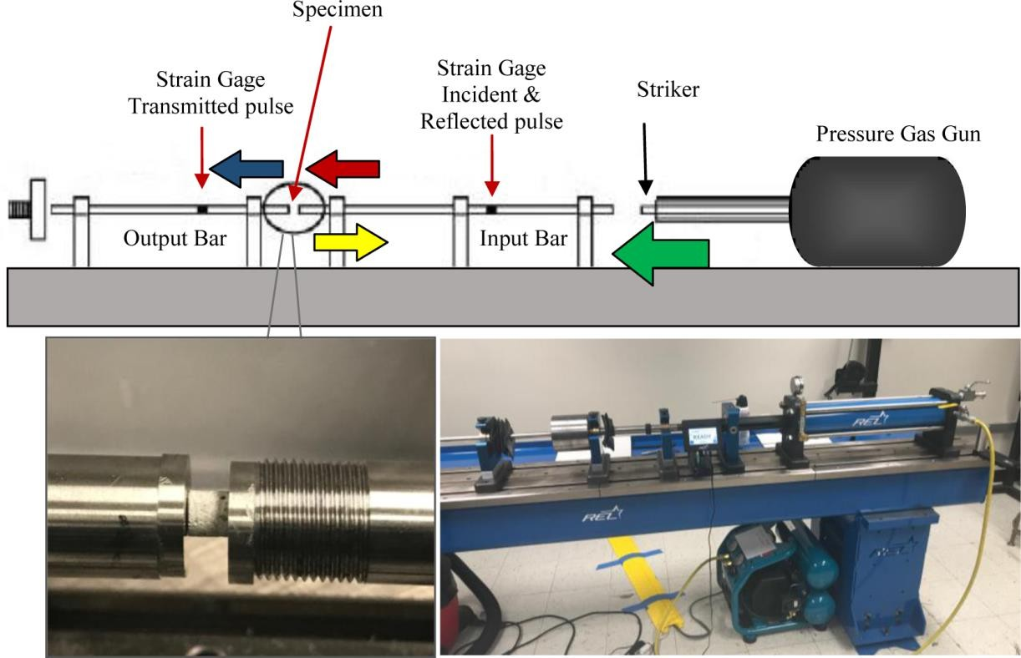

Figure 7. Schematics of Split Hopkinson Pressure Bar (SHPB) apparatus.
For SHPB tests on quasi-brittle materials, the specimen must comply with certain dimension requirements such that the stresses along the length of the sample are uniform during the loading. Five to ten wave reverberations within the specimen is generally required (Lindholm 1971).
Specimens that are prepared with low L/D ratios may have apparently increased strengths caused by the friction at the interface between the specimen ends and the input and output bars. Based on these considerations, the LWCC specimens were prepared to have 12 mm in diameter and 12 mm in length (L/D=1).
Figure 8 (a) presents the dynamic stress-strain curves of specimens tested under different strain rates. The compressive stresses rise to the maximum values followed by a sharp drop featuring strain softening and granular flow. The shapes of the stress-strain curves tested under

different rates are similar while the compressive strength of LWCCs is strain-rate sensitive, see Figure 8 (b) – i.e., the compressive strength of the same material tested under quasi-static condition is 22.97 MPa. At the strain rate of 400 s⁻¹, the dynamic compressive strength is 32.2 MPa which is about 40% higher than quasi-static strength. As the strain rate increases, the maximum stress increases where the dynamic strength are 48.5% and 66.7% higher than static strength for strain rates of 600 s⁻¹ and 920 s⁻¹, respectively. The crack propagation of LWCC under impact loading (400 s⁻¹) is recorded using a high-speed camera and is presented in Figure 8 (c).
Downloaded from ascelibrary.org by University of Liverpool on 07/22/25. Copyright ASCE. For personal use only; all rights reserved.
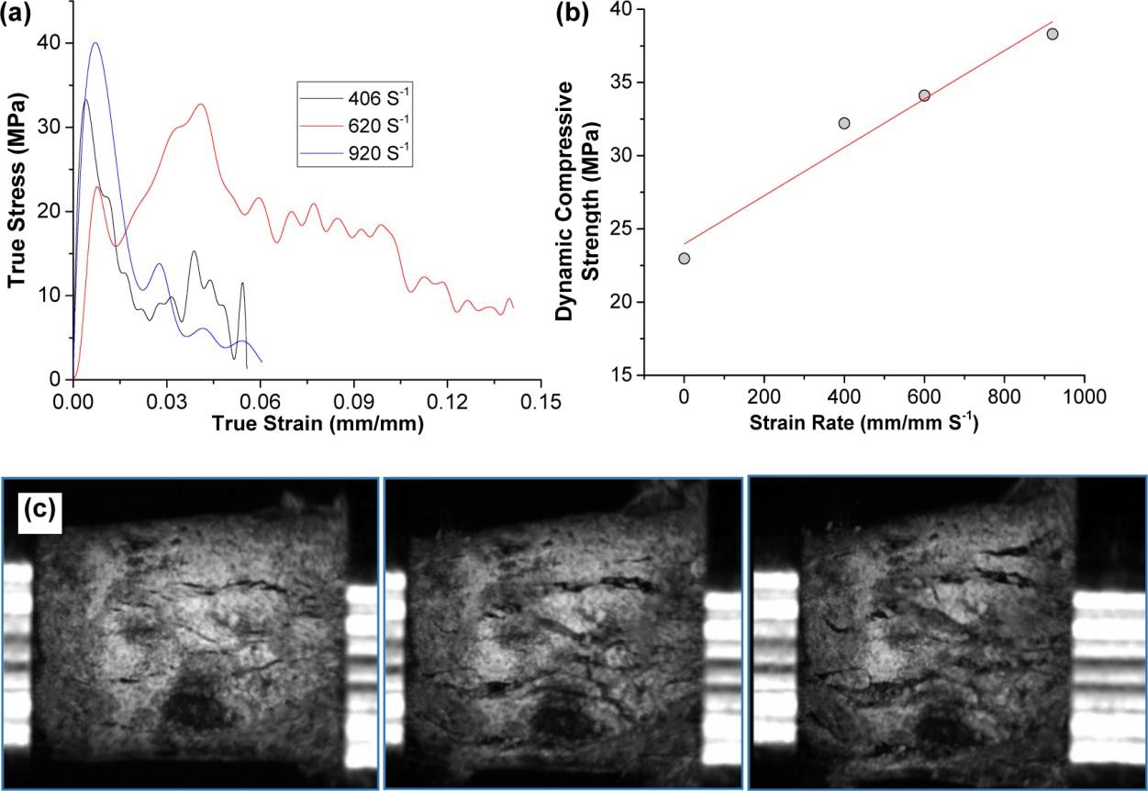
Figure 8. Dynamic behavior of LWCC tested using SHPB: (a) stress-strain curves; (b) dynamic compressive strength as a function of strain rate; and (c) propagation of stress cracks within LWCC under impact.

CONCLUSIONS
A comprehensive study on lightweight cementitious composites (LWCC) incorporating various types of lightweight filler (LWF) materials (i.e., hollow glass microspheres (HGM) and fly ash cenospheres (FAC)) was conducted to evaluate the influence of LWFs and their corresponding particle properties on both the mechanical and thermophysical properties of LWCC. The microstructural properties were analyzed and key parameters governing thermal and mechanical properties of the material are discussed. Lastly, the behavior of LWCC under dynamic compressive loading is examined using Split Hopkinson Pressure Bar (SHPB) tests.
The following conclusions are drawn from this study:
- The thermal properties (i.e., thermal conductivity and specific heat capacity) of LWCCs are primarily dictated by the volume fraction of LWF and they are insensitive to the type of LWF used; on the other hand, the mechanical properties of LWCC are greatly affected by the LWF particle properties including the size, shell thickness (stiffness), and crushing

strength of the particles.
Downloaded from ascelibrary.org by University of Liverpool on 07/22/25. Copyright ASCE. For personal use only; all rights reserved.
- Because of the high strength-to-unit weight ratio, most fly ash cenospheres (FAC) and hollow glass microspheres (HGM) with higher density (e.g., S60) are suitable for producing lightweight cementitious composite (LWCC) materials that may be used for structural load bearing, as long as the LWF volume fraction is controlled within a reasonable range. Cautions should be taken when using large size FACs in the LWCC mixtures (e.g., E200/600 studied in this research), as their large particle size (i.e., > 500 μm) may change the rheological property of the fresh mortar mix and cause workability issues.
- SEM imaging performed on LWCC samples indicated that smaller size LWF particles are well distributed in the cementitious matrix during mixing, despite their very low densities. Thus, these lightweight fillers may be suitable for extrusion based additive construction.
- The Split Hopkinson Pressure Bar (SHPB) tests performed on LWCC indicate that the compressive behavior LWCC is strain rate sensitive. More systematic study is desired to understand the material behavior under high strain-rate loading.

REFERENCES
Aglan, H., Shebl, S., Morsy, M., Calhoun, M., Harding, H., Ahmad, M. (2009). “Strength and toughness improvement of cement binders using expandable thermoplastic microspheres.” Constr Build Mate, 23(8), 2856–2861.
ASTM International. (2005). “Standard Test Method for Thermal Performance of Building Materials and Envelope Assemblies by Means of a Hot Box Apparatus.” ASTM C1363, West Conshohocken, PA.
Bos, F., Wolfs, R., Ahmed, Z., Salet, T. (2016). “Additive manufacturing of concrete in construction: potentials and challenges of 3D concrete printing.” Virtual Phys Prototyp, 11(3), 209-225.
Buswell, R.A., Soar, R.C., Gibb, A.G.F., Thorpe, A. (2006). “Freeform Construction: Mega- scale Rapid Manufacturing for construction.” Autom Constr, 16(2), 224–231.
Clarke, J.L., ed. (1993). Structural Lightweight Aggregate Concrete. Blackie Academic & Professional, Glasgow, UK.
Hanif, A., Lu, Z., Cheng, Y., Diao, S., Li, Z. (2017) .“Effects of Different Lightweight Functional Fillers for Use in Cementitious Composites.” Int J Concr Struct Mater, 11(1), 99– 113.
Hanif, A., Parthasarathy, P., Ma, H., Fan, T., Li, Z. (2017). “Properties improvement of fly ash cenosphere modified cement pastes using nano silica.” Cem Concr Compo, 81, 35–48.
Huang, X., Ranade, R., Zhang, Q., Ni, W., Li, V.C. (2013). “Mechanical and thermal properties of green lightweight engineered cementitious composites.” Constr Build Mater, 48, 954–960.
ISO. (2008). “Plastics - Determination of thermal conductivity and thermal diffusivity - Part 2: Transient plane source method.” ISA 22007-2, International Organization for Standardization, Geneva, Switzerland.
Lindholm, U.S. (1971). “High strain rate tests.” Chapter in Measurement of Mechanical Properties, Volume V, Part 1, Bunshah R.F., ed. Interscience, New York, NY, 199.
Log, T., Gustafsson, S. (1995). “Transient Plane Source (TPS) technique for measuring thermal transport properties of building material.” Fire Mater, 19(1), 43–49.
Oreshkin, D., Semenov, V., Rozovskaya, T. (2016). “Properties of Light-weight Extruded

Concrete with Hollow Glass Microspheres.” Procedia Eng, 153, 638–643.
Downloaded from ascelibrary.org by University of Liverpool on 07/22/25. Copyright ASCE. For personal use only; all rights reserved.
Wu, P., Wang, J., Wang, X. (2016). “A critical review of the use of 3-D printing in the construction industry”. Autom Constr, 68, 21-31.
Yasar, E., Atis, C.D., Kilic, A., Gulsen, H. (2003). “Strength properties of lightweight concrete made with basaltic pumice and fly ash.” Mater Lett, 57(15), 2267–2270.
Zhang, Q., Li, V.C. (2015). “Development of durable spray-applied fire-resistive Engineered Cementitious Composites (SFR-ECC).” Cem Concr Compos, 60, 10–16.
3M. (2009). “Product Information: 3M Glass Bubbles K Series, S Series and iM Series.” 3M, St.
Paul, MN

